Tool Shed Duathlon
ATHLETE GUIDE
Updated August 11th, 2021

Welcome to the 2021 Tool Shed Duathlon! Please read over the athlete guide carefully. It is your responsibility to read the most up-to-date document so you are aware of all of the happenings prior to and on race day.

We are sanctioned and insured by Triathlon Alberta!

Package Pick Up:
Friday, August 13th 10 – 6pm
Saturday, August 14th 10 – 12pm
Tri It Multisport (1703 10th Ave SW)
Packages will not be available outside these hours.
THERE WILL BE NO RACE DAY PACKAGE PICK-UP. You may have someone else collect your package with proof (ie. a text) giving them permission to pick up your package.

Items that will be in your race pack include:
- Race bib
- Safety pins
- Tool Shed Duathlon T-shirt
- Tool Shed Duathlon sticker
- Base Performance bars, gels and salt

Race Day: Sunday, August 15th
6:30am – Transition Opens
7:40am – Transition Closes
7:40am – Pre-Race Meeting - any last-minute changes will be communicated to you on the day.
7:50am – all men start
8:00am – all women start
9:00am – finish area opens – we encourage you to BRING A LAWN CHAIR and hang out post-race!
10:30am – awards ceremony
11:00am – course closes

Transition:
*You will pick up your timing chip and get body marked race morning at the Tri It tent just outside of transition. Please have your bib with you to ensure you collect the correct chip and get body marked with the correct number.

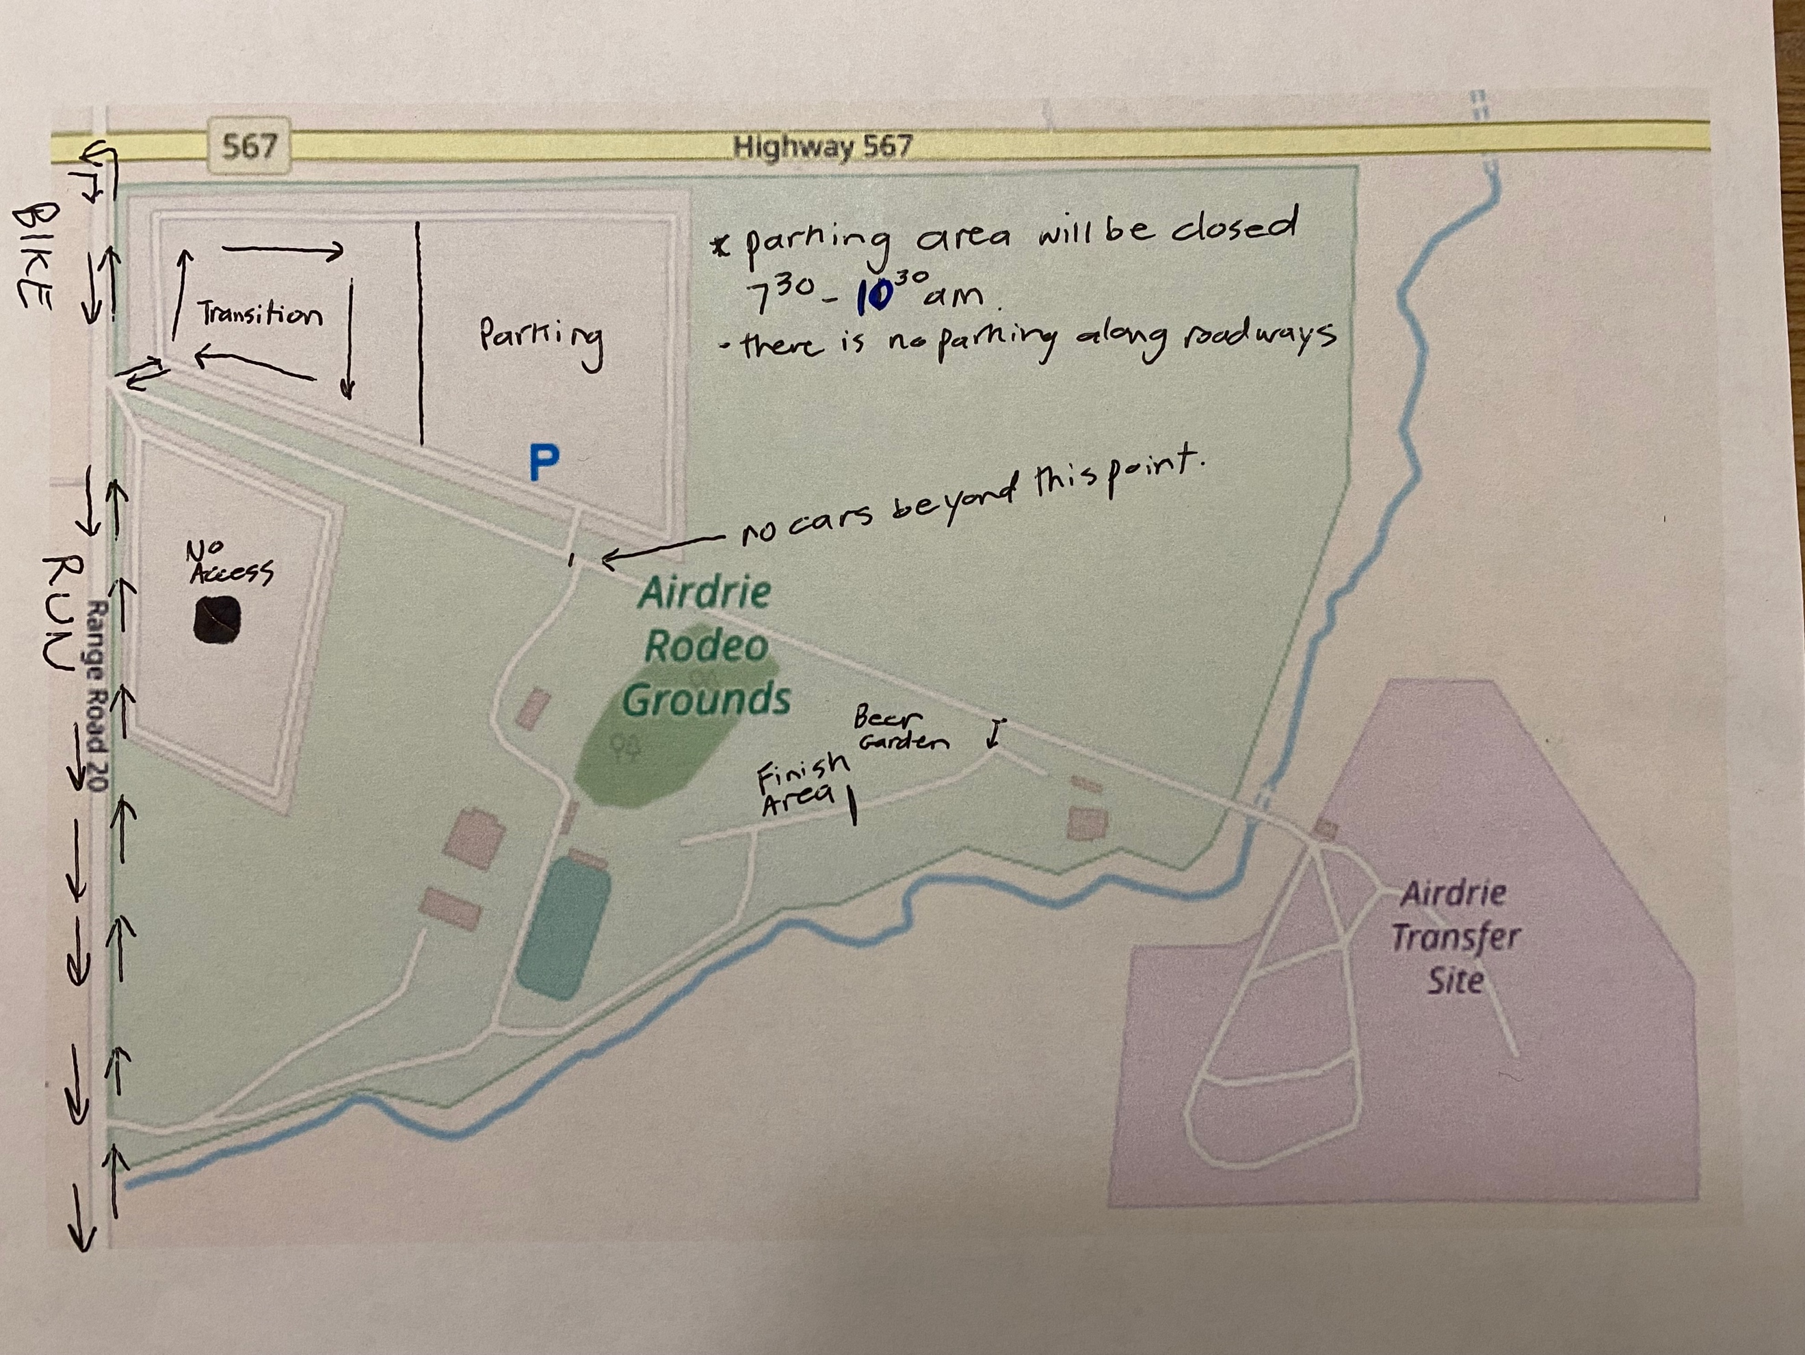

- You will be allowed to store your belongings with your bike in transition. Please make your bags as small as you can manage. NO TUPPERWARE BINS will be permitted. You are not permitted to mark your spot in transition with flags, balloons, etc.
- Officials and competitors only allowed in transition.
- Race numbers must be on front or with use of a number belt, back on the bike, and front for the run.
- No marking position in transition.
- Competitors may not use communication devices of any type, including but not limited to mobile phones, smart watches, and two-way radios, in any distractive manner during the race.
- No bikes will be allowed out of transition until notified by the race director.
- No nudity in transition.
- Glass containers must not be used at any time.
- Please show your race number to gain access.
Run Course (5km):
The run course is all on rural gravel road. All runners must stay within the pylons for both out and back on the 5km course (2.5km out-and-back). The second run will be 300m longer to run to the finish line. NO HEADPHONES OR CELLPHONES PERMITTED ON COURSE. Competitors must carry their own water/nutrition on course. There will be no aid on course.

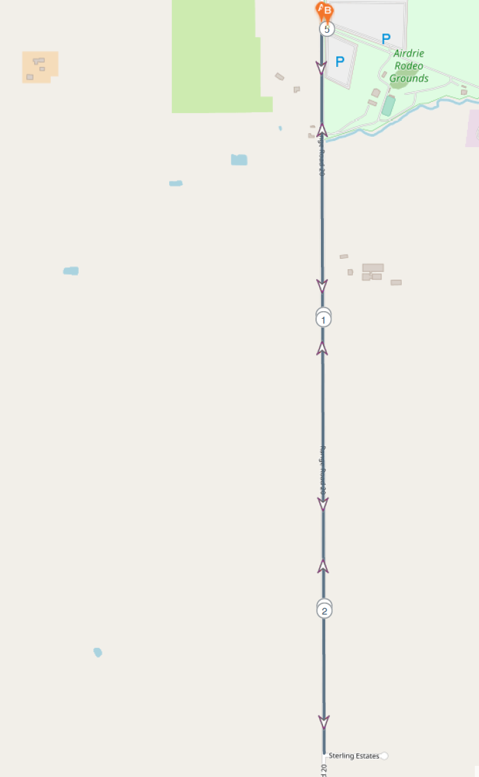

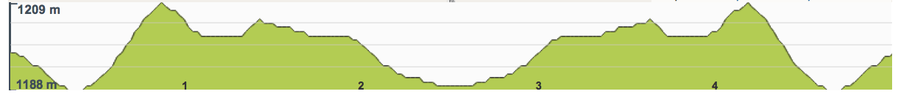

Bike Course (21km):
NOTE: NOTE: Cyclists must ride in a single file as close as practical to the right-hand curb or the edge of the road. NO HEADPHONES OR CELLPHONES PERMITTED ON COURSE. NO MIRRORS ARE ALLOWED. Competitors must carry their own water/nutrition on course. There will be no aid on course.

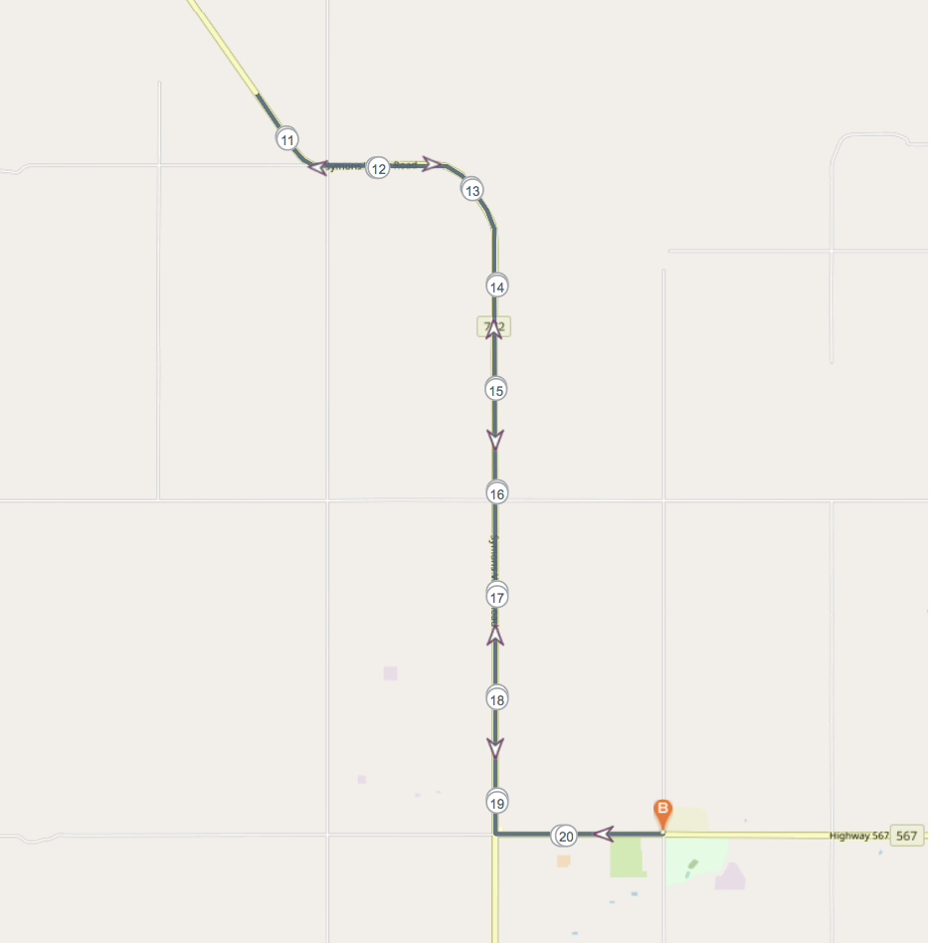

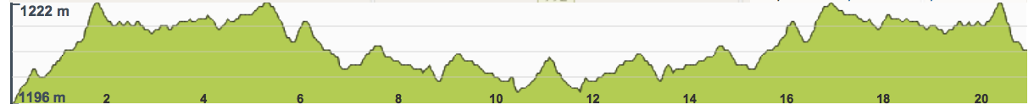

Competitors must follow the prescribed course route in all segments of the race as defined by the race organization. The bike course will have distance markers and signs indicating turns. Cyclists should keep to the right at all times, except when passing. There will be volunteers to tell you of an upcoming corner or turn-around. Please obey all volunteer and certified flaggers instructions. There will be certified flaggers at all intersections where cyclists DO NOT have the right of way or it is necessary for safety reasons. Bike course are “controlled” to traffic but not “closed” to traffic. A “controlled” course means may vehicles may be on the course during the race. Certified flaggers will stop vehicular traffic at all intersections to give cyclists the right of way. It is your responsibility to follow all traffic rules and be aware of any traffic that may be on the course.

Drafting: Drafting of another competitor or motor vehicle is prohibited on the bike course. The draft zone surrounding each competitor measures from the front edge of the front wheel. Competitors have 15 seconds to pass through this zone when overtaking another athlete.
Blocking: Cyclists should keep to the right at all times, unless passing. Alert fellow cyclists of your intention to pass by saying, “on your left”. The drafting zone for non-drafting age group competitions is 5 metres long X 2 metres wide for non ITU qualifying races. Drafting is not permitted in any race. Riding next to someone is blocking. This is not permitted. Both blocking and drafting have time penalties. Repeated penalties will result in disqualification.

Helmets: Helmets are compulsory and must be ANSI/SNELL approved. Chin straps must be fastened anytime the athlete is in possession of the bicycle. This means that before the bike is removed from the rack, the chin strap must be fastened and remain fastened until the bike is placed back on the racks.

Riding of bicycles in the transition zone is strictly prohibited at all times. The bike can only be mounted or dismounted at the mount/dismount line outside of the Transition Zone.

Outside Assistance: Competitors may not receive assistance at any time during the race, or in the transition zone. (This excludes medical or safety assistance given by designated race volunteers or qualified staff.)

Unsportsmanlike Conduct: Verbal or physical abuse of officials and race volunteers is not acceptable or tolerated.

Torsos: All athletes must have their torsos covered on the bike and run portions of the event. Bib numbers must be visible on the bike and run courses. Ensure your bib is visible upon nearing the finish line to ensure the race announcer can call out your name.

Water Stations: There will be no water/aid stations available at the event. This includes the on-course cycle water station. Refill stations will be available at the event venue if you would like to fill up your water bottles in transition.

Competitors are ultimately responsible for their own safety and for the safety of others. Competitors must take responsibility for knowing the technical and competition rules and for abiding by them. It is the competitor’s responsibility to be properly prepared for an event and to ensure his or her equipment is suitable and fit for its intended purpose, including his or her bike, which must be roadworthy.

FAILURE TO COMPLY WITH THESE RULES OR DISREGARDING RACE OFFICIALS REQUESTS MAY LEAD TO DISQUALIFICATION.

General Information Race Venue

Parking: Parking will be located on site. However, vehicles must be parked PRIOR to transition closing (7:40am) and will not be permitted to leave until the course closes (10:30am).

First aid and emergencies: we will have medical staff on site. The rear of your race bib is printed with space for you to fill out any preexisting medical conditions. Please fill this in with any pre-existing medical conditions, or if there are none then just write N/A. This allows our medical team to provide you with the correct treatment as quickly as possible should something happen.

Spectators: Due to covid-19 and wanting to limit the number of people within the venue, we are discouraging spectators from attending this year.

Waste and Litter Management:
We will provide black refuse bags at the race venue, please use these to place all litter in. If you use energy bars or gels, please take these to the end with you, or drop them in the designated litter zone by transition. Littering on-course is a violation of the rules and can result in a penalty.

Toilet Facilities:
We will be providing porta-potties at the race venue which will be located in transition.

Timing and Results: Your results will be streamed live online and will be available from our timing partner Startline Timing at: www.startlinetiming.com For any timing enquiries or discrepancies please contact them directly, using the email info@startlinetiming.com as the race director cannot make any changes.

Awards: awards will be given to the top M and F in each 10-year age group
18 - 19 year olds
20 - 29 AG
30 - 39 AG
40 - 49 AG
50 - 59 AG
60 + AG

